# Adding and Removing a User Role in SQL

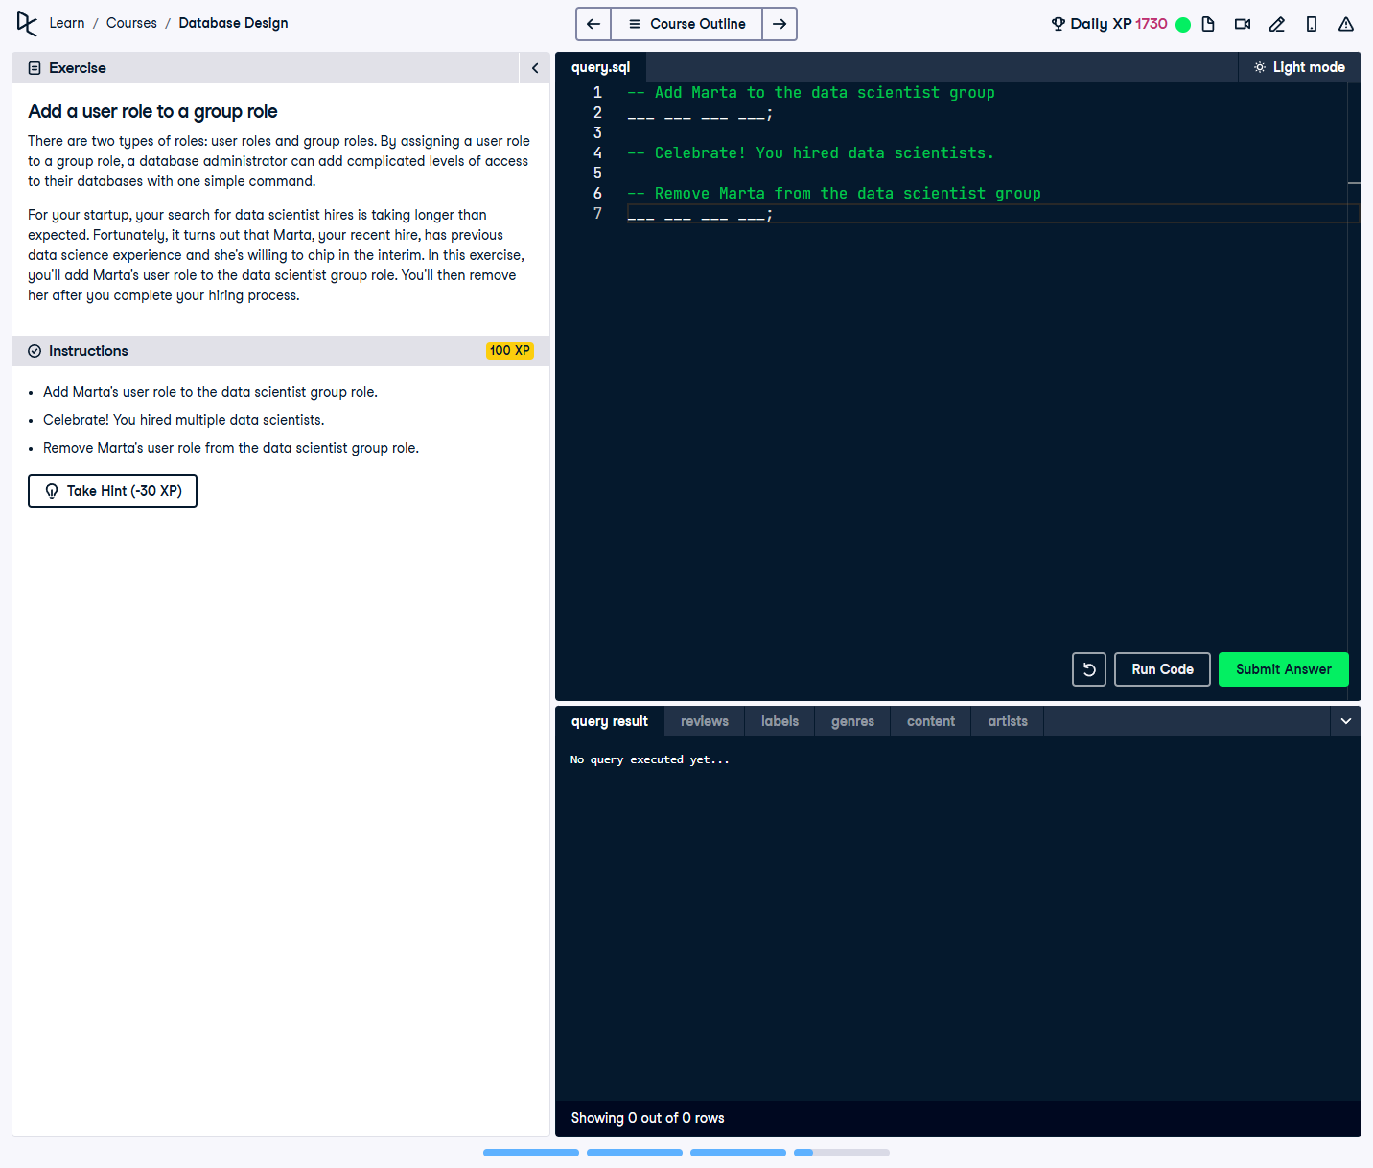

## Question:

In this exercise, you need to:  
1. Add Marta's user role to the `data_scientist` group role.  
2. Celebrate hiring multiple data scientists!  
3. Remove Marta’s user role from the `data_scientist` group role.

## Full Answer (SQL Code):

-- Add Marta to the data scientist group  
GRANT data_scientist TO marta;  
  
-- Celebrate! You hired multiple data scientists.  
  
-- Remove Marta from the data scientist group  
REVOKE data_scientist FROM marta;

## Explanation of the Answer:

The `GRANT` statement assigns Marta to the `data_scientist` role, giving her access to its privileges. After hiring more data scientists, the `REVOKE` statement removes Marta from the `data_scientist` role, revoking the privileges associated with that role.